Instructions to run Bigfit program:

In Cmder do the following:

1. Navigate to c:\temp

2. Clone project to c:\temp

git clone <https://github.com/SVILLACORTA/BigFit.git>

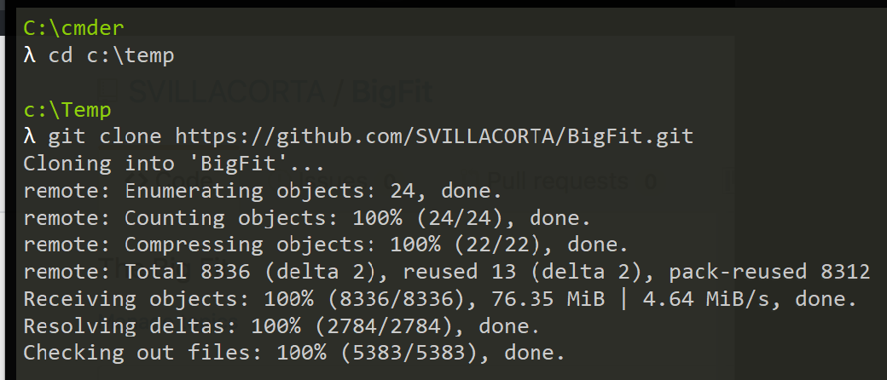

3. cd c:\temp\BigFit\Bigfitproject

4. python manage.py runserver

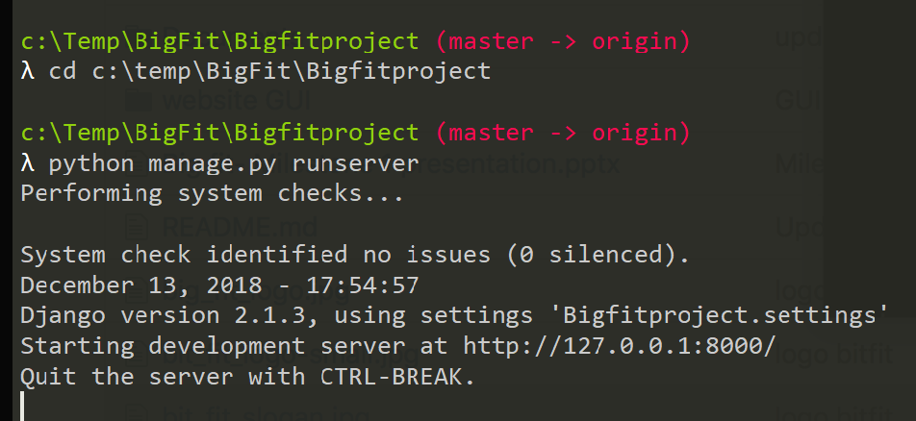

5. Open a web browser and type in http://localhost:8000/home in the URL bar

